**Whiskey Whiskers® Current Preamplifier**

Jerry A. Yang

# **Overview**

The Whiskey Whiskers® current preamplifier is a high-gain, high-bandwidth precision current preamplifier with six orders of magnitude of dynamic range. It is intended to be used in conjunction with the Whiskey Whiskers® high-speed data acquisition system.

## ***Key Features***

* Dynamic range of 10-11 to 10-3 A
* High gain-bandwidth product (GBW) up to 600 MHz at 1010 V/A
* Signal-to-noise ratio of >10 dB
* Output signals between ±9 V, with reference signal at 500 mV
* 2.1 x 5.5 mm barrel jack for 24 V DC power
* BNC terminals for input current signal and output voltage signal
* Two dual BNC jacks for digital/software gain-select

# **Circuit Schematic and Design**

Figure 1 shows a simplified schematic of the current preamplifier. The SPM current input is modeled as an AC current in parallel with a 50 pF capacitor. The 50 pF capacitor represents the BNC cable capacitance (1 ft BNC cable = about 25 pF). Two stages, a transimpedance stage and a voltage amplification stage, along with two filters, are the building blocks of the circuit. The transimpedance stage amplifies the input current to either 10 mV or 100 mV using a variable feedback resistor (also called a gain-setting resistor) controlled by switching circuitry. A feedback capacitor, whose value is dependent on the resistor, is used to prevent instability issues (e. g. ringing and peaking) associated with purely resistive circuits at high frequencies. An additional RC network is added to the positive input terminal of the transimpedance amplifier, which is recommended by the manufacturer of the selected amplifier to reduce noise. The post-amp voltage amplification stage is a traditional non-inverting op amp circuit that amplifies the voltage output of the TIA to 500 mV. Each section of the circuit is explained in detail below.

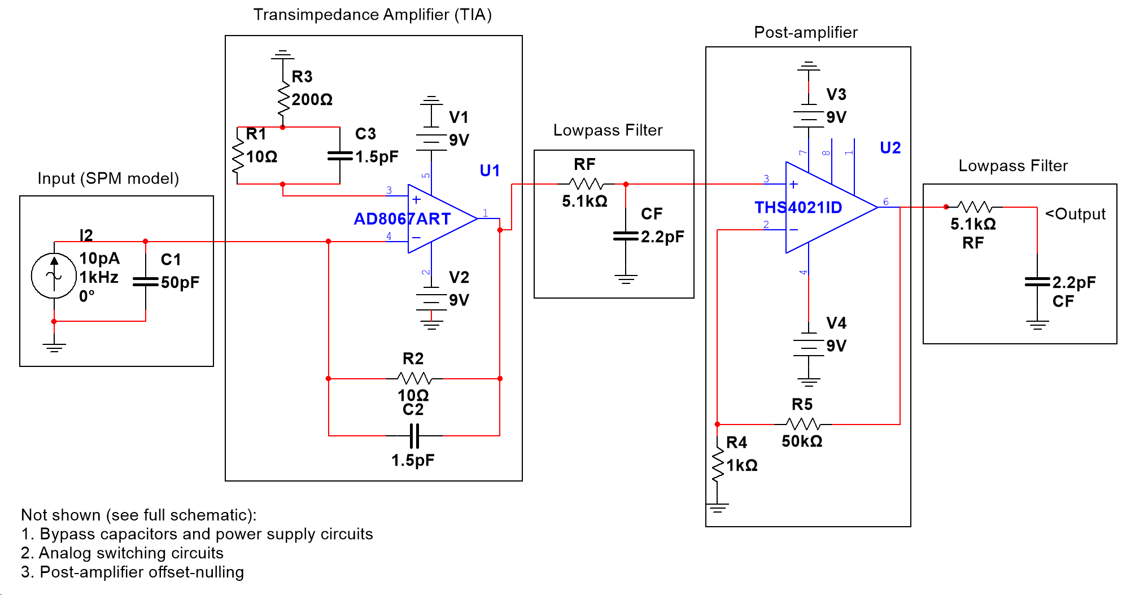

Figure 1. Current preamplifier circuit schematic

## ***Transimpedance Amplifier***

A transimpedance amplifier (TIA) converts input current signals into output voltage signals (Figure 2). Transimpedance amplifiers work by application of Ohm’s law: in Figure 2, the gain is given by

$$V_{out}=-R_{f}I_{in}.$$

Because the inverting terminal of the op amp has high impedance, a (mostly) negligible current is passed into the op amp, and the remainder of the current travels through the feedback branch. When the current passes through the feedback resistance $R_{f}$, a voltage develops across the terminals of $R_{f}$, which sets the output voltage. The feedback resistance is called the transimpedance gain – different from the voltage gain. A transimpedance amplifier is limited to an inverting topology because the op amp must use negative feedback; there is no simple way to design a transimpedance amplifier that both uses positive feedback and remains stable. As a result, the transimpedance amplifier inverts and amplifies the input signal.

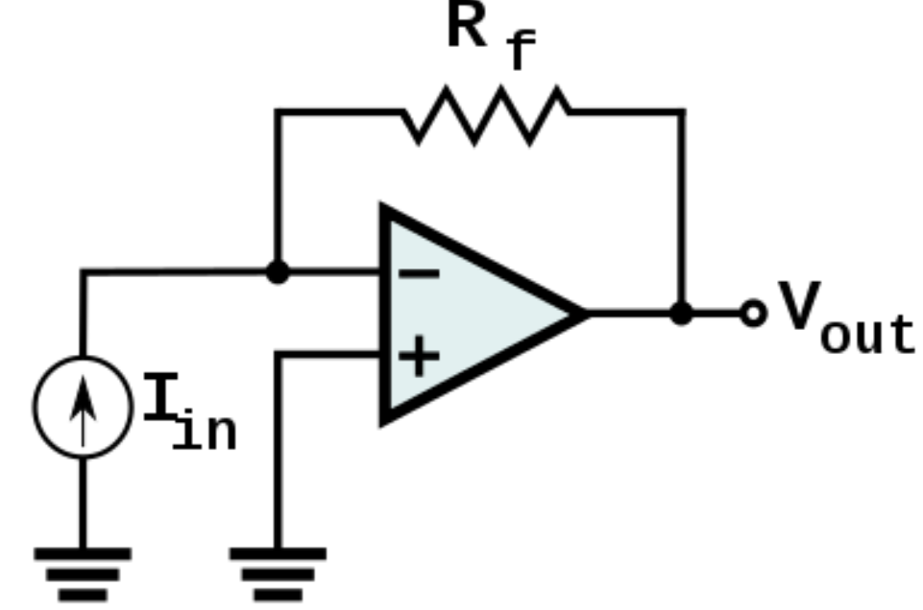

Figure 2. Transimpedance amplifier

The transimpedance amplifier is an example of a linear system. Linear systems exhibit a tradeoff between gain and bandwidth, which is often modeled as a constant, called the gain-bandwidth product (GBW). The gain-bandwidth product is defined as

$$GBW=G*BW,$$

where the gain is the gain of the amplifier, and the bandwidth is the region of desired frequencies that the linear system operates at. In an ideal scenario, the gain-bandwidth product would be the only parameter needed to optimize the current preamplifier, and the largest gain-bandwidth product would yield the most ideal amplifier. However, in reality, the gain-bandwidth product can change over gains and frequencies, but it is useful as an initial ad-hoc model for frequency analysis. Other factors, such as frequency, stability, noise, and the performance limitations of extant op amp technologies, limit the design and construction of the current preamplifier.

The gain-bandwidth product is an imprecise measurement of the frequency response of an operational amplifier. For a general transimpedance amplifier, the maximum frequency at which the actual gain will be greater than 70.7% of its theoretical gain, also called the cutoff frequency, is given by the equation

$$f_{-3dB}= \sqrt{\frac{GBW}{2πR_{f}C_{in}}},$$

where $C_{in}$ is the input capacitance at the terminals of the op amp. The input capacitance is the capacitance of the input cable added to the stray capacitances at the op amp terminals and is a source of noise. Because the SPM can take a data point at one particular time (DC) or complete a scan of a region (AC) at a sampling rate of up to 4 MHz, the bandwidth that the current preamplifier needs to operate within is from 0 to 4 MHz. Assuming that the GBW is 1 GHz (state-of-the-art for practical amplifiers) and that the input capacitance is 25 pF (another optimistic value), the largest theoretically possible transimpedance gain for the amplifier is

$$4MHz= \sqrt{\frac{1 GHz}{2πR_{f}\left(25pF\right)}}→R_{f}=1.5*{10}^{6} Ω.$$

Most amplifiers unfortunately do not have such high gain-bandwidth products, and in practical applications, state-of-the-art amplifiers often exhibit another tradeoff between gain-bandwidth product and noise. Higher gain-bandwidth products often require operation over a wider dynamic range of signals, which reduces their precision and sensitivity. Noise considerations are discussed later. Furthermore, the cutoff frequency, and therefore the bandwidth, has an inverse-square root relationship with the gain. Increasing the gain by a factor of four will result in halving the possible bandwidth. It is therefore exceedingly difficult (if not impossible) to achieve full gain over the entire bandwidth for signals smaller than a few micro-amps with current state-of-the-art amplifier technology. In addition, stability and noise compensation will limit the practical frequency response to only a fraction of the theoretical response.

The transimpedance amplifier circuit, like many other amplifier circuits, also has stability issues stemming from the pole in the frequency domain that is formed between the feedback resistor and the input capacitance. This pole will cause a large spike in transimpedance gain near the cutoff frequency, which is called overshoot or peaking. Overshoot may cause ringing at the amplifier output, where a large amount of noise from harmonics and higher frequencies enter the output signal. To cancel this pole, we must add a compensation capacitor (also called a feedback capacitor) in the feedback loop of the transimpedance amplifier to create a zero in the frequency domain at the cutoff frequency. Figure 3 shows the effect of a feedback capacitor on the simulated frequency response of a transimpedance amplifier circuit. In the top plot, the simulation predicts an overshoot of two orders of magnitude, which can easily saturate the amplifier. In the bottom plot, the simulation predicts no overshoot but reduced bandwidth, as the additional RC network slows the response time of the circuit. A ballpark value for the feedback capacitor can be calculated by setting the desired zero to the cutoff frequency pole:

$$f_{-3dB}=\frac{1}{2πR_{f}C_{f}}=\sqrt{\frac{GBW}{2πR_{f}C_{in}}},$$

where $C_{f}$ is the desired feedback capacitor. After some rearranging, the equation above becomes:

$$C_{f}=\sqrt{\frac{C_{in}}{2πR_{f}GBW}}.$$

In practice, the compensation capacitor is optimized based on simulation and prototyped results, as other factors such as board wire capacitance and wire inductance add a small amount of capacitance to each trace, which may cause significant changes in the frequency response, especially at extremely high gains. Some amplifier datasheets give application notes on what compensation topology is best suited for the transimpedance amplifier configuration as well.

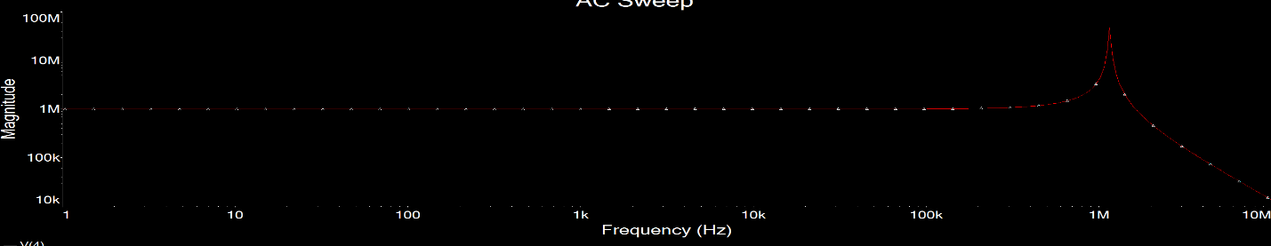

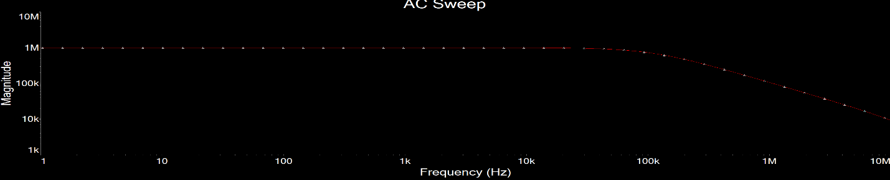

Figure 3. Simulated frequency response of a transimpedance amplifier circuit (top) without a compensation capacitor, and (bottom) with a compensation capacitor.

Noise is the final major consideration in selecting and designing a transimpedance amplifier circuit. Noise issues are best mitigated in the careful selection of an operational amplifier; many op amps provide common noise characteristics in their datasheets. Noise can be divided into two categories: DC noise and AC noise. Many datasheets have different terms for DC and AC noise, but they all represent the same phenomena. Table 1 shows various forms of noise, their definition, their source, and their effect on the output signal. DC noise is frequency-independent noise that appears at the output as a DC offset on the signal. For example, if a transimpedance amplifier has an input offset voltage of 0.2 mV and the gain is set to 10,000, the output signal will have a DC offset of 2 V, which can saturate the amplifier if the input AC signal is 1 mV peak-to-peak. Offset-nulling circuit topologies exist, and some amplifiers come with offset nulling functionality that usually involved tying a potentiometer between two terminals of the op amp and tuning the potentiometer to give an input offset voltage of close to 0 V. AC noise is frequency-dependent. The total AC noise contributed by a system is equal to the root-mean-square of the sources. While there is not a great way to decrease the AC noise in the system without using overly complicated topologies (e.g. bootstrapping), lowpass or bandpass filters can be placed at each stage of the amplifier circuit to ensure that noise outside the desired frequency band is removed from the signal. First-order RC filters are sufficient, but Butterworth and high-orders could be used to obtain better transfer characteristics.

Noise in the transimpedance amplifier can be modeled as input-referred noise or output-referred noise, where the output-referred noise value is equal to the input-referred noise amplified by the ideal gain. This concept is particularly useful because there are many sources of AC noise in a transimpedance amplifier circuit, which can then be combined and treated as a single noise source, simplifying the noise analysis.

We can measure the effect of noise on a signal with the signal-to-noise ratio (SNR). The signal-to-noise ratio is the ratio of the signal to noise at a certain point of the system. Depending on the input SNR, we can calculate the output SNR by the formula

$$SNR=20\log{\frac{signal}{noise}}.$$

The noise factor is defined as how much noise gets added to the signal after each amplification step and can be calculated as

$$F=\frac{SNR_{i}}{SNR_{o}},$$

where $SNR_{i}$ represents the input SNR and $SNR_{o}$ represents the output SNR. The noise figure is defined as $NF=20 \log{F}.$ These definitions can be used to quantify the possible noise characteristics of the transimpedance amplifier. Assuming that all noise is input-referred and the input current has no noise, the output SNR of the transimpedance amplifier is given by

$$SNR_{o}=20 \log{\frac{current}{op amp noise}}.$$

This is the starting SNR prior to the post-amplifiers, which will contribute additional noise. As mentioned above, the SNR can be improved with lowpass filters on the output terminal, which reduces much of the high-frequency noise that may contribute to SNR degradation.

Table 1. Transimpedance Amplifier Noise Phenomena

|  |  |  |  |
| --- | --- | --- | --- |
| Type of Noise | Definition | Source | Effect |
| Input offset voltage | Voltage difference between input terminals of op amp | Op amp transistor non-idealities | DC offset voltage on output; can be nulled with circuits |
| Input offset current | Current difference between input terminals of op amp | Op amp transistor non-idealities | Generally not important for TIAs |
| Input bias voltage | Voltage necessary to bias internal op amp transistors | Op amp transistor non-idealities | Generally not important for TIAs |
| Input bias current | Current necessary to bias the internal op amp transistors, flows into terminals of op amp | Op amp transistor non-idealities | Some of the input current signal has to go into op amp, so less current going through feedback path, which causes output error |
| Input voltage noise | Small voltage fluctuations at input terminals  (Flicker aka 1/f noise at low freq; shot noise at high freq) | Op amp transistor non-idealities | Disproportionately affects frequencies less than 100 Hz; distorted AC response |
| Input current noise | Small current fluctuations at input terminals | Op amp transistor non-idealities | Disproportionately affects frequencies less than 100 Hz; distorted AC response |
| Output voltage noise | Small voltage fluctuations at output terminal | Op amp transistor non-idealities | Usually not dominant source of noise, eclipsed by other noise sources |
| Thermal noise | Thermal excitation of charge carriers in resistors | Feedback resistor | $R_{f}$ is inversely proportional to thermal noise |
| Input Capacitance | Capacitance on the input terminals | Op amp terminals, PCB capacitance, input wire (e.g. BNC) capacitance | Reduces bandwidth |

The gain-bandwidth product, noise considerations, and performance limitations can be optimized by careful selection of a high-speed, low-noise operational amplifier (op amp). For this current preamplifier, we selected the AD8067 for its wide power rails, dual supply, high gain-bandwidth product, low input bias current, low input capacitance, and low input current noise. Based on the equations above, the output SNR is about 25-50 dB depending on the gain resistor and the input signal. Other amplifiers, such as the OPA846, LMH6629, LTC6268, and MAX477 had better SNRs but had either single-supply terminals or narrow supply rails, making them unsuitable to capture a wide range of signals. In addition, the LT1222, LT1226, LM7171, OPAx192, and THS4021 all featured wide power supply rails but had high input bias currents, unsuitable for sensitive measurements below 100 nA. Other considerations for optimizing the SNR include short input cables from the SPM to the current preamplifier and variable lowpass filters that can be tuned to filter noise above the desired sampling rate, which may not always sample at 4 MHz.

Our current preamplifier uses software-controlled switching circuitry to set the output voltage to either 10 mV or 1 mV depending on the rated input current. Larger input currents (1 mA to 0.1 uA) are amplified to 10 mV, whereas smaller input currents (10 nA to 100 pA) are amplified to 1 mV. This reduces the size of the gain-setting resistor necessary for small input currents, thereby increasing the bandwidth of the signal at the expense of a smaller SNR. However, the large feedback resistance still dominates the frequency response of the amplifier.

Another design note: Due to the extreme precision and sensitivity that the SPM data acquisition system requires, noise issues force the transimpedance amplifier gain to be set so that the input signal will be amplified above the noise floor (the voltage level of noise on the output). Therefore, if we needed to amplify a 100 pA signal, we cannot simply set the transimpedance gain to 104 V/A and use subsequent post-amps to amplify the TIA signal to 106 V/A because the 100 pA signal would be amplified to 1 uV. Because the AD8067 has a noise floor of about 5 uV in the 4 MHz bandwidth, the signal would become indistinguishable from noise. The noise floor of the AD8067 is about 2 mV unfiltered and 5 uV with a 4 MHz lowpass filter on the output. As will be discussed later, noise issues are best minimized by placing as much gain as possible on the first amplifier on the circuit, in this case the transimpedance amplifier (but also taking into consideration bandwidth tradeoffs).

## ***Post-Amplifier***

The post-amplifier amplifies the signal from the transimpedance amplifier by one more stage before being passed to the output lowpass filter and is a typical off-the-shelf non-inverting op amp circuit. This amplifier does not limit the performance as much as the transimpedance amplifier does, but it is still necessary to consider the gain-bandwidth product and its contribution to noise in the current preamplifier design. We selected the THS4021 amplifier due to its reasonably high gain-bandwidth product and offset-nulling capabilities.

In our design, the post-amplifier amplifies the output signal from the transimpedance amplifier to 500 mV by providing either 50 V/V gain for large input SPM currents or 500 V/V for small input SPM currents. Because the gain-setting resistor on the transimpedance amplifier effectively sets the frequency response of the system due to its sheer size, the post-amplifier only needs to have a gain-bandwidth product greater than the gain of the post-amplifier times the cutoff frequency of the transimpedance amplifier. For example, a gain of 105 on the transimpedance amplifier (corresponding to 10 nA input reference current) has a bandwidth of only 2 MHz. As long as the post-amplifier has a gain-bandwidth product of $2 MHz*500=1 GHz$, the post-amplifier will only minimally reduce the bandwidth of the entire system. In the current preamplifier design, if the gain is set to a small enough value that the bandwidth of the transimpedance amplifier is 4 MHz, the post-amplifier will have a gain of 50 V/V so that the maximum gain-bandwidth product necessary is 200 MHz at high speeds. The THS4021 has a gain-bandwidth product of 3.5 GHz, suitable for the current preamplifier.

Three main considerations affect the noise in the post-amplifier: topology, power supply, and input offset voltage. First, inverting op amp circuits tend to have more components in the signal path, which therefore generates more noisy signals. The THS4021 contains a chart of the source resistance (resistance on the positive input terminal) and noise figure for frequency 10 Hz. The noise figure is frequency-dependent, so the source resistance may need to be tuned accordingly. Second, the power supply must be wide enough to accommodate large AC signals. Third, because the post-amplifier is a voltage-gain op amp, the input offset voltage is amplified along with the input signal. This can be a concern if the signal is small, as most input offset voltages can range from uV to mV. However, the THS4021 (and various other amplifiers) provides offset-nulling functionality that can reduce the input offset voltage to less than 100 uV with a trimmer potentiometer (trimpot). The trimpot can be tuned to minimize the output voltage noise. It is also useful to add another lowpass filter on its output to remove any unwanted high-frequency noise.

The post-amplifier also degrades the output SNR, as it contributes its input-referred noise to the system. This can be quantified in a similar way as the transimpedance amplifier with noise factor and noise figure. To calculate the SNR/noise degradation of the entire current amplifier, we can use the Friis formula:

$$F=F_{1}+\frac{F_{2}-1}{G_{1}}+\frac{F_{3}-1}{G_{1}G_{2}}+…$$

Because the gain on the transimpedance amplifier is at least 10, the noise degradation of the entire system is dominated by the transimpedance amplifier; the additional input-referred noise contributed by the post-amplifier will be an order of magnitude smaller than that of the transimpedance amplifier. Thus, the AC noise from the post-amplifier is essentially negligible. In practice, the additional noise may cause an SNR degradation of a few decibels.

## ***Gain-Setting***

Gain-setting is a key part of the current preamplifier, as it allows users to change the dynamic range of signals being captured. The gains of the transimpedance amplifier and post-amplifier are set with analog multiplexers (also called analog switches). The MUX36S08 is an 8-to-1 multiplexer used to select between the eight different possible gains on the transimpedance amplifier, and the TMUX6136 is a 2-to-1 multiplexer that selects between the 50 V/V and 500 V/V options on the post-amplifier.

Several considerations factor into the selection of analog multiplexers: supply range, leakage current, and on-resistance. The analog multiplexers must be able to accommodate signals that may go from rail-to-rail on the op amps. This requires the analog multiplexers to have a wide supply, from -9 V to 9 V. In addition, the leakage currents for each channel must be at least an order of magnitude smaller than the signal; otherwise, the signal can experience distortions from other channels. The on-resistance is a significant issue if the multiplexer is placed in the feedback loop of the amplifiers, as it can add to the nominal feedback resistance already present. To prevent this, two multiplexers are used outside the feedback path to control the signal path: one between the output terminal of the op amp and the feedback node, and one between the feedback node and the next stage of the circuit (Figure 4). The op amp still drives current through its output terminal to maintain the voltage of the feedback nodes to $-I_{in}R_{f}$ by Ohm’s Law regardless of the analog multiplexer’s on-resistance, hence the analog multiplexer’s on-resistance does not affect the value of the gain anymore. However, this design results in a non-planar circuit for more than two feedback resistances. Good PCB design can mitigate the additional noise caused by non-planarity.

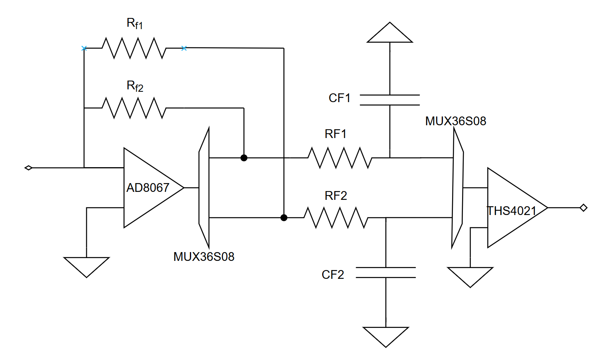

Figure 4. Gain-setting with analog multiplexers (trapezoids)

The analog multiplexers use four analog select lines to control the gains, which are controlled by digital ports on the NI DAQ. The digital ports create four constant voltages that are passed to the current preamplifier through the dual BNC jacks on the top of the PCB. The port assignments and truth table are listed in Table 2. The MUX36S08 has three select lines labeled A0, A1, and A2. The post-amplifier has one select line.

Table 2. Truth Table for Gain-select

|  |  |  |  |  |  |  |  |
| --- | --- | --- | --- | --- | --- | --- | --- |
| Signal Range | Reference Current | TIA Gain  (V/A) | Post-amp Gain  (V/V) | A0  P2.4 | A1  P2.6 | A2  P2.0 | Post-amp  P2.7 |
| 0.1 mA – 10 mA | 1 mA | 101 | 50 | 0 | 0 | 0 | 0 |
| 10 uA – 1mA | 100 uA | 102 | 50 | 0 | 0 | 1 | 0 |
| 1uA – 100 uA | 10 uA | 103 | 50 | 0 | 1 | 0 | 0 |
| 100 nA – 10 uA | 1 uA | 104 | 50 | 0 | 1 | 1 | 0 |
| 10 nA – 1 uA | 100 nA | 105 | 50 | 1 | 0 | 0 | 0 |
| 5 nA – 100 nA | 10 nA | 105 | 500 | 1 | 0 | 0 | 1 |
| 0.5 nA – 10 nA | 1 nA | 106 | 500 | 1 | 0 | 1 | 1 |
| 50 pA – 1 nA | 100 pA | 107 | 500 | 1 | 1 | 0 | 1 |
| 10 pA – 100 pA | 10 pA | 108 | 500 | 1 | 1 | 1 | 1 |

*Note.* DAQ digital ports P2.4 (pin 2) and P2.6 (pin 1) should be grounded to pin 35, and ports P2.0 (pin 37) and P2.7 (pin 39) should be grounded to pin 36.

## ***Power Considerations***

The analog channels on the NI PIX1E DAQ module have an input voltage rating of 11 V. Ideally, it would be possible to have signals up to ±11 V from the current preamplifier. However, to ensure that spikes in the signal do not destroy the analog channels, we set the power rails for the op amps to ±9 V. The power supply circuit for both the transimpedance amplifier and the post-amplifier also require two bypass capacitors (6.8uF polarized tantalum, 100 pF ceramic) on their power rails to prevent sharp spikes or dips in the power supply from frying the op amps. These capacitors should be placed as close to the power terminals of the op amps as possible. In addition, the current preamplifier contains an isolated DC-DC converter to convert the 24 V DC power line from the barrel jack to ±9 V supply rails. The isolated DC-DC converter (NMH2409DC, Murata Power Solutions) can draw up to 110 mA from the power source, which is shared between all ICs on the board.

# **Inputs and Outputs**

The current preamplifier features 6 female BNC jacks: two single jacks for the input and output of the circuit, and two dual jacks for gain selection. The input single jack is placed as close as possible to the negative terminal of the AD8067 amplifier to prevent signal degradation along the trace and is intended to be connected to the SPM tip. The output single jack is placed on the opposite edge of the PCB next to the lowpass filter of the post-amplifier output signal and is intended to be connected to analog channel an0 (pin 68, AIO+; ground pin 67) on the NI DAQ with a BNC-to-leads connector. The four input lines of the two dual jacks are connected to the select lines of the analog multiplexers and are intended to be connected to digital channels on the NI DAQ with BNC-to-leads connectors. DAQ digital ports P2.4 (pin 2) and P2.6 (pin 1) should be grounded to pin 35, and ports P2.0 (pin 37) and P2.7 (pin 39) should be grounded to pin 36.

# **Bandwidth/Stability Charts**

The bandwidth chart below contains the bandwidth of the current preamplifier and overshoot in the frequency domain, as predicted by Multisim 14.1. An AC sweep was run from 1 kHz to 5 MHz for each gain. The current preamplifier model used to produce these values is Figure 1. C2 and C3 are optimized to minimize the overshoot and bandwidth in the TIA. An input source capacitance of 50 pF (~2 ft BNC cable) was included in the model.

|  |  |  |  |  |  |  |  |
| --- | --- | --- | --- | --- | --- | --- | --- |
| Signal Range | Reference Current | TIA Gain | C2 | C3 | TIA Bandwidth | Post-amp Bandwidth | Overshoot |
| 0.1 mA – 10 mA | 1 mA | 101 | 1.5p | 1.5p | >4 Mhz | >4 Mhz | <0.5% |
| 10 uA – 1mA | 100 uA | 102 | 1.5p | 1.5p | >4 Mhz | >4 Mhz | <0.6% |
| 1uA – 100 uA | 10 uA | 103 | 1.5p | 1.5p | >4 Mhz | >4 Mhz | 4% |
| 100 nA – 10 uA | 1 uA | 104 | 2.2p | 2.2n | >4 Mhz | >4 Mhz | 9% |
| 10 nA – 1 uA | 100 nA | 105 | .75p | 68p | 3.1 MHz | 2.7 MHz | 4% |
| 5 nA – 100 nA | 10 nA | 105 | .75p | 68p | 3.1 MHz | 1 MHz | 4% |
| 0.5 nA – 10 nA | 1 nA | 106 | 0.3p | 75p | 750 kHz | 200 kHz | None |
| 50 pA – 1 nA | 100 pA | 107 | 0.3p | 0.3p | 55 kHz | 35 kHz | None |
| 10 pA – 100 pA | 10 pA | 108 | 0.3p | 0.3p | 5 kHz | 5 kHz | None |

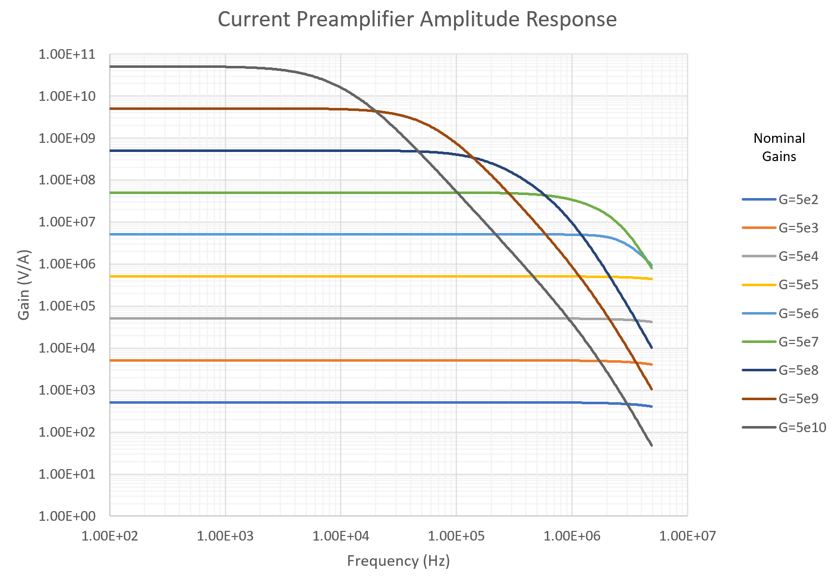

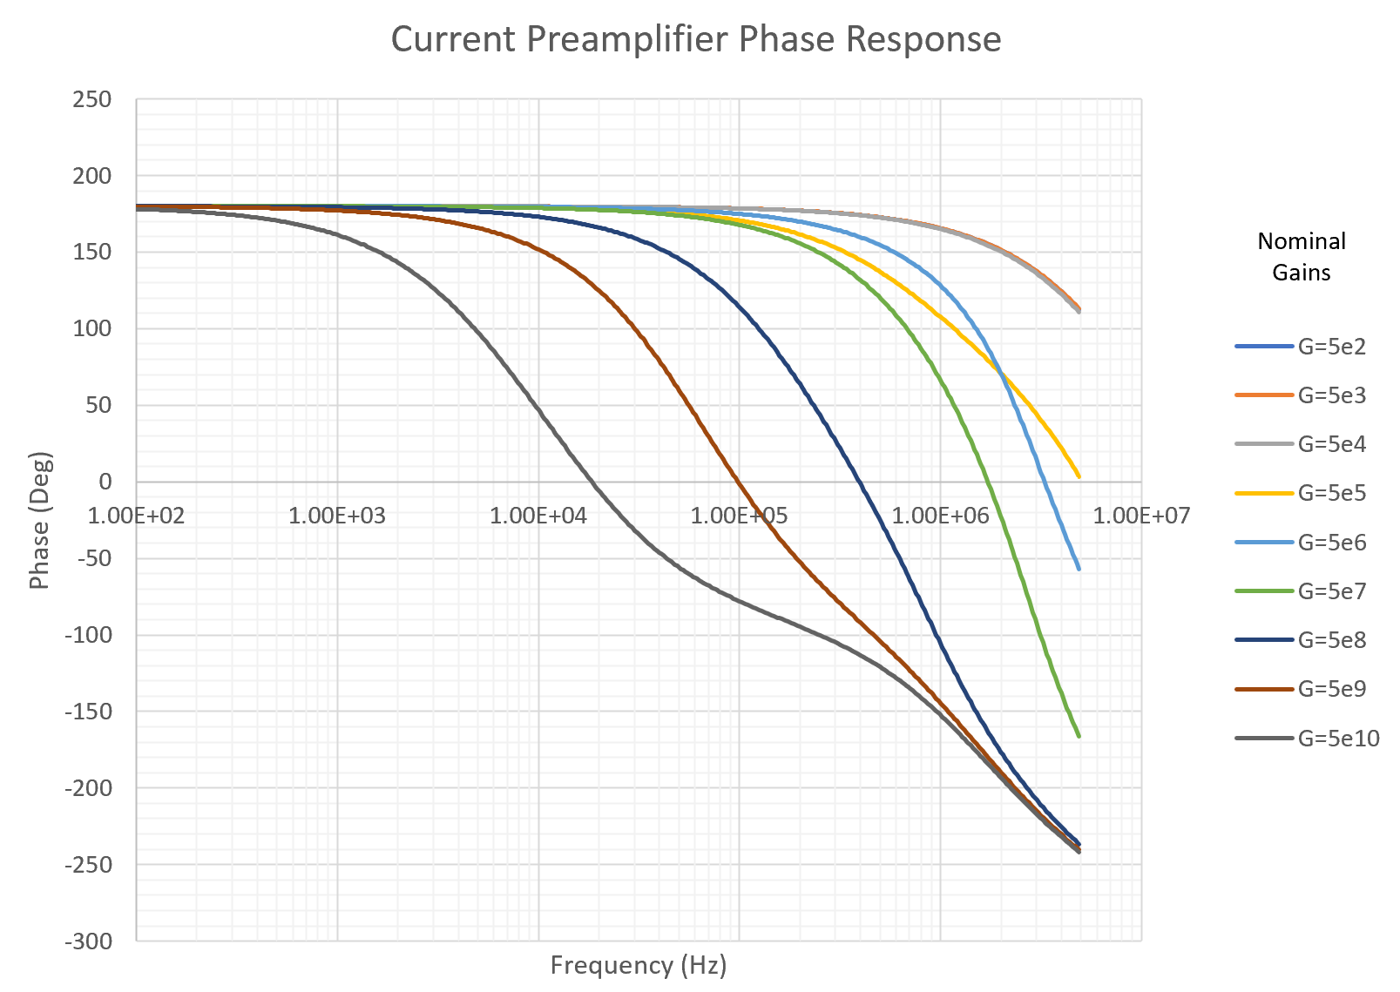

# **Noise Charts**

The noise chart below contains the value of the output-referred noise from the TIA and the total circuit at each gain. Noise analysis was completed using Figure 1 and the noise analysis feature (not the noise figure feature) in Multisim 14.1. The TIA output signal is either 10 mV or 1 mV, and the total output signal is 500 mV. RF and CF indicate the values of the RC filters on the TIA and post-amp outputs. RF and CF must be tailored to the bandwidth and cutoff frequency to prevent noise greater than the desired bandwidth from entering the signal (important for high gains).

|  |  |  |  |  |  |  |
| --- | --- | --- | --- | --- | --- | --- |
| Signal Range | Reference Current | Total Gain  (V/A) | RF | CF | Bandwidth | Integrated Total Noise |
| 0.1 mA – 10 mA | 1 mA | 5x102 | 5.1 kΩ | 2.2 pF | >4 Mhz | 2 mV |
| 10 uA – 1mA | 100 uA | 5x103 | 5.1 kΩ | 2.2 pF | >4 Mhz | 2 mV |
| 1uA – 100 uA | 10 uA | 5x104 | 5.1 kΩ | 2.2 pF | >4 Mhz | 3 mV |
| 100 nA – 10 uA | 1 uA | 5x105 | 5.1 kΩ | 2.2 pF | >4 Mhz | 20 mV |
| 10 nA – 1 uA | 100 nA | 5x106 | 5.1 kΩ | 4.7 pF | 2.7 MHz | 37 mV |
| 5 nA – 100 nA | 10 nA | 5x107 | 5.1 kΩ | 15 pF | 1 MHz | 115 mV |
| 0.5 nA – 10 nA | 1 nA | 5x108 | 5.1 kΩ | 0.1 nF | 200 kHz | 120 mV |
| 50 pA – 1 nA | 100 pA | 5x109 | 5.1 kΩ | 0.47 nF | 35 kHz | 87 mV |
| 10 pA – 100 pA | 10 pA | 5x1010 | 5.1 kΩ | 2.2 nF | 5 kHz | 68 mV |

*Note.* When using the preamplifier at high gains, the lower end of the signal range may be sunk in noise, so be sure to select the current range appropriately depending on the minimum signal input signal. The processing software accommodates about 10 dB SNR, so the minimum input signal must be amplified to at least 4x the integrated noise.

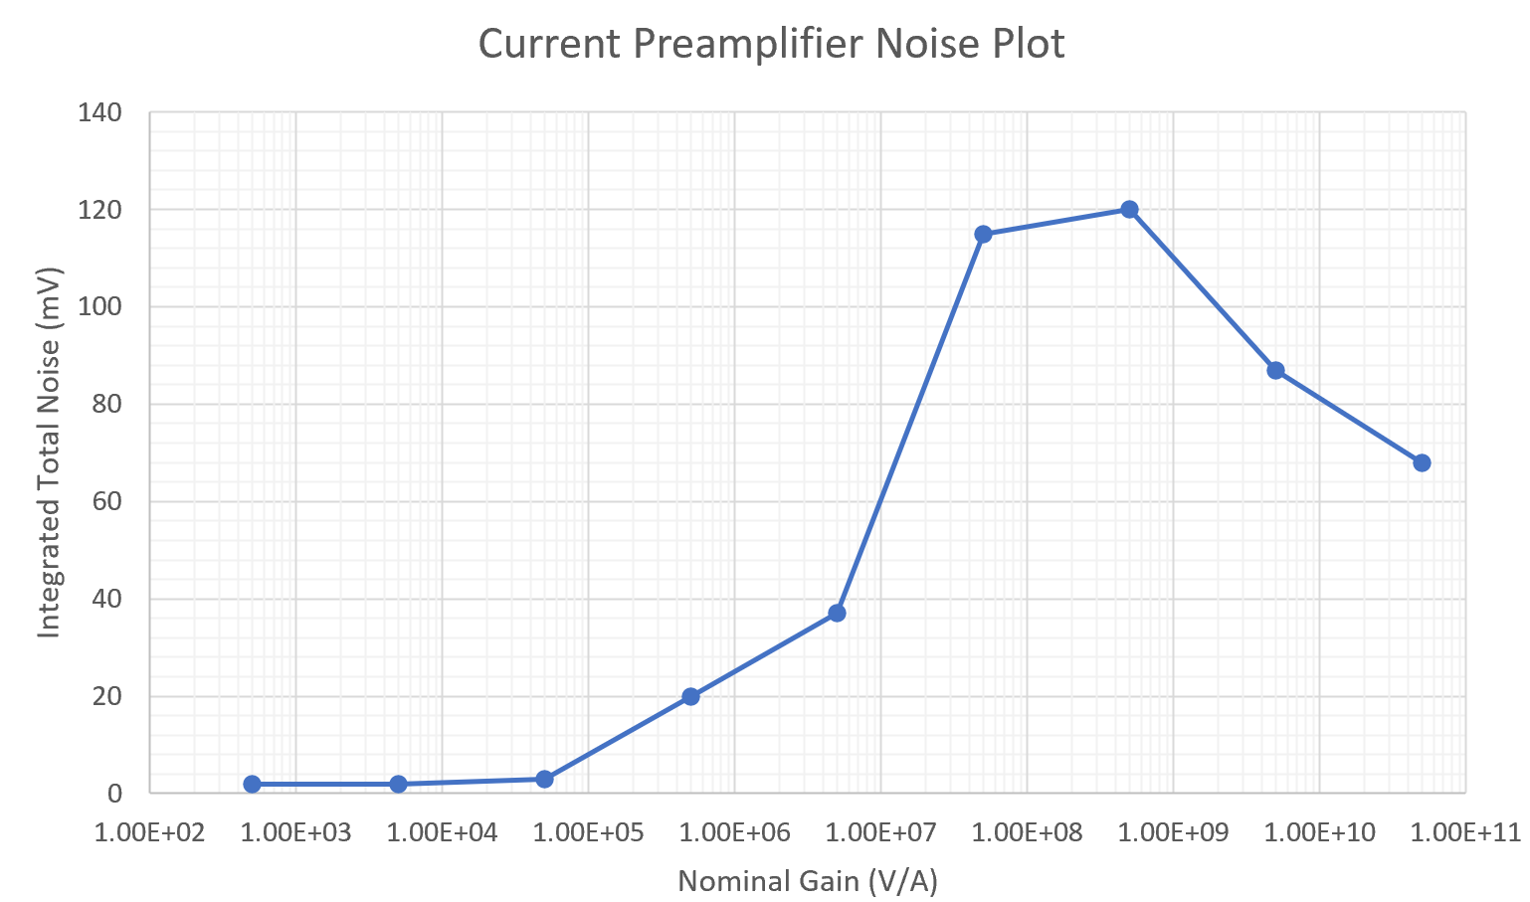

A dominant source of noise comes from the on-resistance of the analog multiplexers in the TIA, which gets amplified by the post-amp. Other sources of noise include the power supply circuits and routing, the digital select lines, the analog multiplexers, the PCB, and environmental noise. The analog multiplexers are likely the largest source of noise that is not considered in the simulation, as they are directly in the signal path. Power supply noise can be reduced with bypass capacitors, as mentioned above. Careful PCB design and routing at right angles can reduce digital noise from entering the analog signal path. Additional electromagnetic interference (EMI) shielding from a metal chassis and a ground plane can mitigate environmental noise.

# **Source Files**

This document should be accompanied by Multisim 14.1 simulation files used to generate the bandwidth and noise charts, KiCAD files, full schematic, BOM, layout, and Gerber files. Initial boards were milled with OSH Park (domestic) and JLCPCB (non-domestic). Both took about 3-4 weeks. The JLCPCB version is optimized to use their SMT assembly service (not optimized for functionality), which has a decent stock of common parts. You still need to hand-solder the through-hole parts as well as the special parts: the AD8067, THS4021, and the analog multiplexers. OSH Park does not provide assembly services; however, the UT ECE department has an industrial-grade reflow oven in their teaching labs. Contact Mark Innmon ([mark.innmon@austin.utexas.edu](mailto:mark.innmon@austin.utexas.edu)) for access.

## ***Known Issues (and Other Design Notes)***

1. The board files provided are for previous iterations of the board and reflect only most of the circuit design. Component values may be off.
2. The OSH Park boards have footprint issues with components R10, R11, and R12.They might not match the BOM.
3. The footprint and pinout for the rocker switch in the BOM is rotated 90 degrees. The pins that are closer to each other are the ones that are connected when the switch is closed. In the KiCAD footprint, 1 is connected to 2 and CON_1 is connected to CON_2.
4. The isolated DC-DC converter footprint should also be checked. NMH2409SC is the SIP package, where all the pins are in one row. NMH2409DC is the DIP package, which has pins on two rows.
5. Multisim seems to have difficulty with simulating anything more complex than Figure 1. I did not try any other software/circuit simulation packages. The bonus is that Multisim has both AD8067 and THS4021 in its component model database, so it does not require additional SPICE model building, which other simulators might not have.
6. The NI DAQ has a sensitivity of about 0.2 mV and accuracy of about 5 mV. The analog channels have a noise standard deviation of about 0.3 mV as well. The DAQ manual is not clear as to what the voltage threshold is for the analog channels, but I would guess that it is no smaller than 10-30 mV. The minimum signal of the preamplifier (100 pA) should be amplified to 50 mV if possible.
7. The Ithaco preamp manual also has gain-bandwidth curves, noise tables, and other characteristics charts. However, I would be careful in interpreting their language because their definition of “sensitivity” is the “minimum signal that could be amplified”, whereas in this document, I use signal ranges and reference values to indicate the magnitude of the amplification. In other words, when they report a sensitivity of 10-9 A/V, that translates to the signal range of 1 nA to 100 nA in this document.
8. The Ithaco preamp contains input overvoltage protection circuitry, which prevents large spikes in current from the SPM from destroying the amplifier (Figure 2 in the user manual). I did not implement any overvoltage circuitry.
9. The Ithaco preamp also contains current suppression circuitry, probably to nullify the input offset current/voltage in the TIA. I did not implement any current suppression (Figure 3.1 in the user manual).
10. Further work must seek to optimize the passive components to get the best frequency response. C2, C3, RF, CF, and Cin (BNC capacitance) all depend on each other. Other work should investigate higher-order and active filters to increase bandwidth. A promising filter topology is the Sallen-Key architecture (shown below), which reduces the 115 mV noise for nominal gain 50 MV/A by two orders of magnitude. The noise is small enough to increase the passband frequency pole to 10 MHz, resulting in a bandwidth of 3 MHz and 6% overshoot. However, this may only work when R2 = R4 and R5 is large enough to dominate the post-amp circuit.

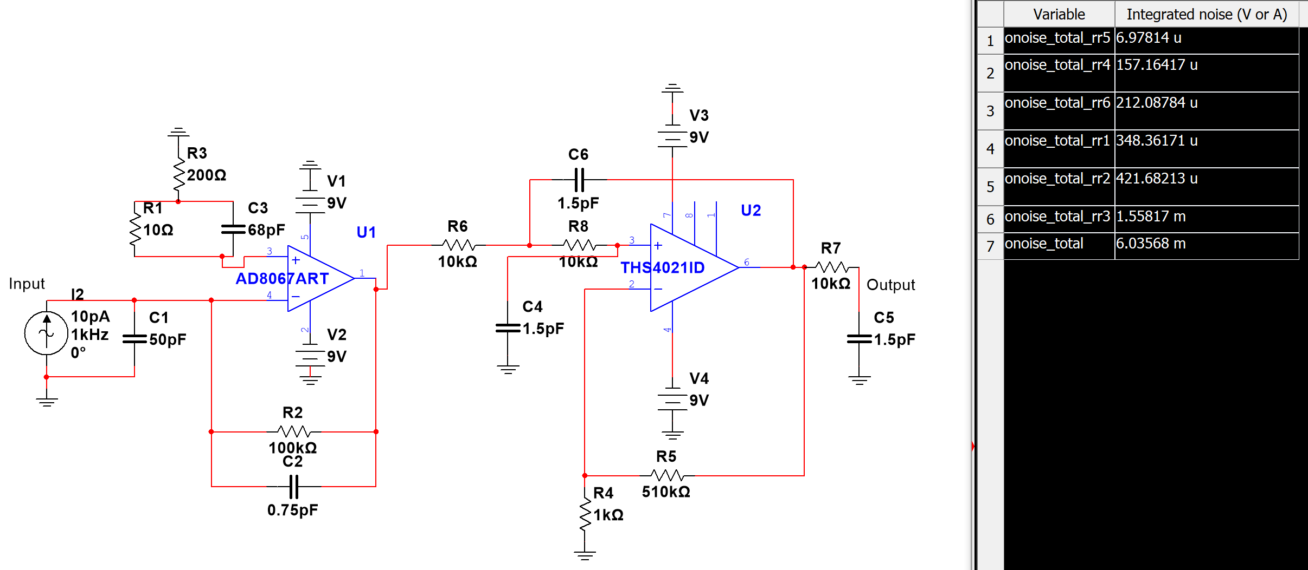

# **Annotated References/Additional Information**

One application area in which TIAs are often used is in amplifying photodiode signals. Photodiode signals often require transimpedance amplification of 104 to get readable signals and have wider-ranging uses, so most of the practical knowledge on designing sensitive, high-gain TIAs have come from sources discussing photodiodes. These references are in no particular order.

|  |  |
| --- | --- |
| [1] | H. Hashemi, “Transimpedance Amplifiers (TIA): Choosing the Best Amplifier for the Job,” Texas Instruments Incorporated, Dallas, TX, Application Report SNOA942A, Nov. 2015.  This application report from Texas Instruments contains a good high-level overview of how to choose an op amp to use in a TIA circuit and gives an example of the decision process with three of TI’s own amplifiers. It also discusses post-TIA amplification in greater detail. Most of the theoretical content in this user guide (and the final preamp design) was developed from this article. |
| [2] | X. Ramus, “Transimpedance Considerations for High-Speed Amplifiers,” Texas Instruments Incorporated, Dallas, TX, Application Report SBOA122, Nov. 2009.  This source is similar to [1], except that it takes a slightly more mathematical approach to choosing a good op amp for a TIA circuit. It is also a good summary of key considerations for TIA design. |
| [3] | P. C. D. Hobbs, “Photodiode Front Ends: The REAL Story,” *Optics & Photonics News,* vol. 12, no. 4, pp. 44-47, Apr. 2001.  This article gives various ideas and circuit topologies for increasing bandwidth using non-traditional circuit topologies. The author discusses bootstrapping, cascodes, and other non-linear devices that may improve bandwidth and SNR. It may provide other ideas to increase bandwidth without sacrificing gain. |
| [4] | *Model 1211 Current Preamplifier,* DL Instruments, Ithaca, NY, USA, 2000.  This manual is the original Ithaco current preamplifier in the lab. It contains a block diagram of the preamp, diagrams for most of the internal circuitry, a bill of materials, and more on the device, but not a lot on the theory of operation. Another datasheet lists the main features of the Ithaco preamp, but does not have as much detail. |
| [5] | J. Ardizzoni, "A Practical Guide to High-Speed PCB Layout", *Analog Dialogue,* vol. 39, no. 9, Sept 2005.  This article gives many practical considerations for high-speed PCB layout. For high-speed amplifier circuits, bypass capacitors on power rails and short trace lengths (smaller distance for signal to travel) were the main takeaways from this article. Other ideas, such as using surface-mount (SMD/SMT) components, ground planes, and vias were also useful. |
| [6] | D. Kleijer, *Op-amp noise calculator.* Accessed on: Apr. 20, 2020. [Online]. Available: <http://dicks-website.eu/noisecalculator/index.html>  This website is an op amp noise calculator. It gives various common op amp topologies and lists the formulas for the noise contribution of each component. The site does not include a transimpedance topology, but it does include a non-inverting and inverting op amp. It is most useful for calculating the noise figure of the post-amplifier, which can then be used to calculate the resulting SNR of the entire current preamplifier with Friis’ Formula. |
| [7] | M. Steffes, “Noise Analysis in High-Speed Op Amps,” Texas Instruments Incorporated, Dallas, TX, Application Report SBOA066A, Oct. 1996.  This application report from TI gives a comprehensive overview of noise analysis for high-speed operational amplifiers. It contains much of the theory and modeling techniques used to calculate spectral noise density and integrated noise. |
| [8] | J. Karki, “Active Low-Pass Filter Design,” Texas Instruments Incorporated, Dallas, TX, Application Report SLOA049B, Sep. 2002.  This application report from TI gives several suggestions for active low-pass filters. It goes into the theory and proposes several types and topologies for higher-order low-pass filters, including the Sallen-Key and multiple feedback (MFB) architectures. Higher-order filters may be able to reduce current preamplifier noise to below DAQ-detectable levels. |
| [9] | L. Orozco, “Programmable-Gain Transimpedance Amplifiers Maximize Dynamic Range in Spectroscopy Systems,” *Analog Dialogue,* vol. 47, no. 5, pp. 1-5, May 2013.  This application report from Analog Devices outlines the theory of operation behind the gain-setting circuit used in the current preamplifier design. The article also notes that parasitic switch capacitances can reduce the bandwidth of the current preamplifier and proposes different solutions to reduce the effect of parasitic capacitances in the analog multiplexers. |